Development of LIBS xxxxxxx

xxxx xxxx¹, xxxx xxxx i¹, xxxx xxxx ², xxxx xxxx ³
¹Graduate School of Advanced Technology and Science, Tokushima University, Tokushima 770-8501, Japan
²xxxxx xxxx xxxx, xxxxx xxxx xxxx, xxxxx xxxx xxxx, xxxx
³ xxxxx xxxx xxxx, xxxxx xxxx xxxx, xxxxx xxxx xxxx, xxxx

Abstract:
Author(s) will be requested to submit 1-page abstract (pdf file) in English. Use A4 size format and type your text in 10.5-point Times (New) Roman, single-spaced. Figures and Tables may be included in the abstract^{[1]}.
................................................................................................................................................................................................................................................................................................

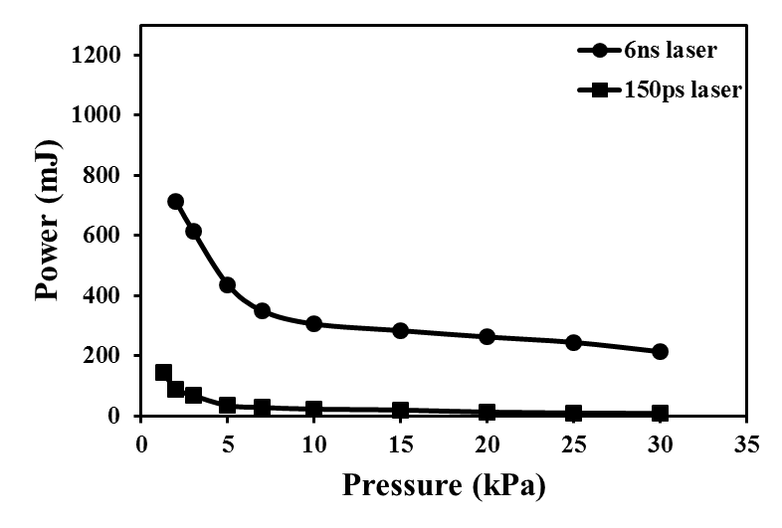
Fig.1 Air plasma generation threshold

References
[1] xxx xxx, xxx xxx, “xxx xxx Using Laser-Induced Breakdown Spectroscopy”. Spectrochim. Acta, Part B. 2002. 57: 701-709.
[2] ..........

